Case Study: City Jail

1. List all criminals along with the crime charges filed. The report needs to include the criminal

ID, name, crime code, and fine amount.

Traditional Method

SELECT crl.criminal_id, crl.first, crl.last, cc.crime_code, cc.fine_amount

FROM crime_charges cc, crimes cr, criminals crl

WHERE cc.crime_id = cr.crime_id AND cr.criminal_id = crl.criminal_id

ORDER BY criminal_id, first, last, crime_code, fine_amount;

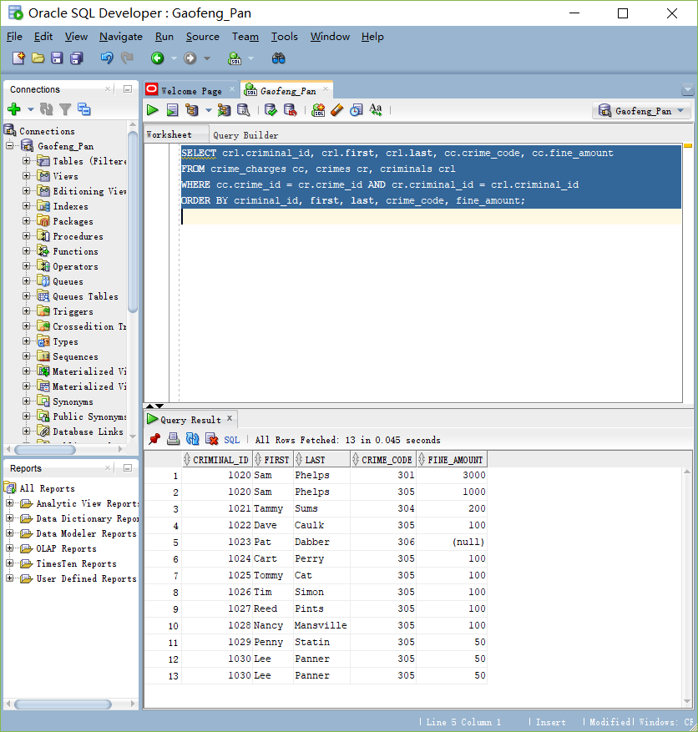

Join Method

SELECT crl.criminal_id, crl.first, crl.last, cc.crime_code, cc.fine_amount

FROM criminals crl

JOIN crimes cr ON cr.criminal_id = crl.criminal_id

JOIN crime_charges cc ON cc.crime_id = cr.crime_id

ORDER BY criminal_id, first, last, crime_code, fine_amount;

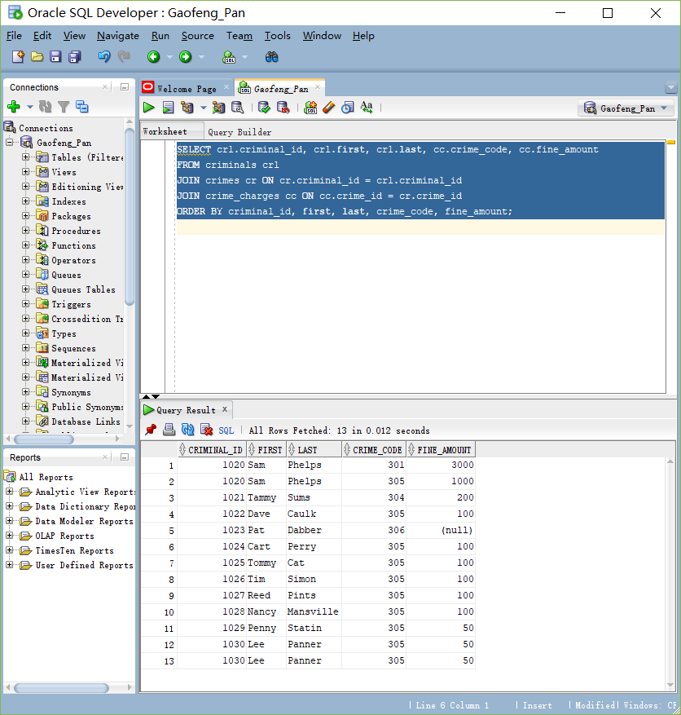

2. List all criminals along with crime status and appeal status (if applicable). The reports need

to include the criminal ID, name, crime classification, date charged, appeal filing date, and

appeal status. Show all criminals, regardless of whether they have filed an appeal.

Traditional Method

SELECT crl.criminal_id, crl.first, crl.last, cr.classification, cr.date_charged, ap.filing_date, ap.status

FROM criminals crl, crimes cr, appeals ap

WHERE crl.criminal_id = cr.criminal_id AND cr.crime_id = ap.crime_id

ORDER BY criminal_id;

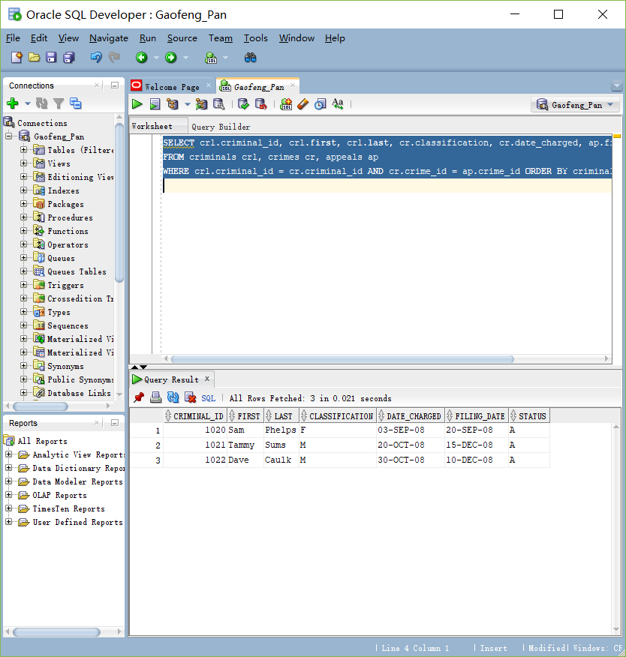

JOIN Method

SELECT crl.criminal_id, crl.first, crl.last, cr.classification, cr.date_charged, ap.filing_date, ap.status

FROM criminals crl

JOIN crimes cr ON cr.criminal_id = crl.criminal_id

JOIN appeals ap ON ap.crime_id = cr.crime_id

ORDER BY criminal_id;

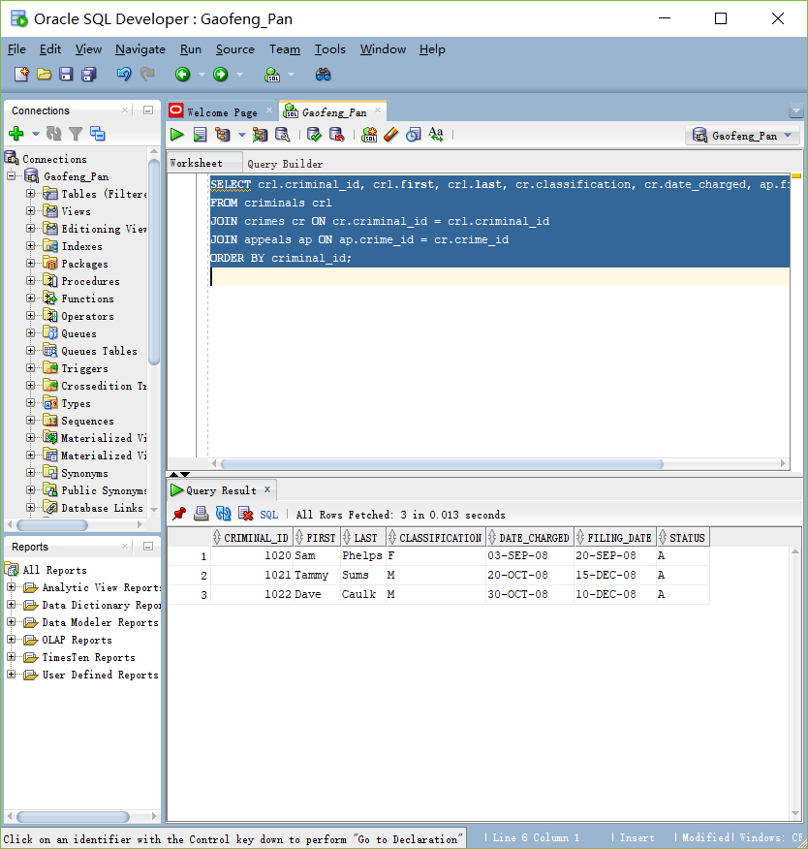

3. List all criminals along with crime information. The report needs to include the criminal ID,

name, crime classification, date charged, crime code, and fine amount. Include only crimes

classified as “Other.” Sort the list by criminal ID and date charged.

Traditional Method

SELECT crl.criminal_id, crl.first, crl.last, cr.classification, cr.date_charged, cc.fine_amount, cc.crime_code

FROM criminals crl, crimes cr, crime_charges cc

WHERE crl.criminal_id = cr.criminal_id AND cr.crime_id = cc.crime_id AND classification = 'O'

ORDER BY criminal_id, date_charged;

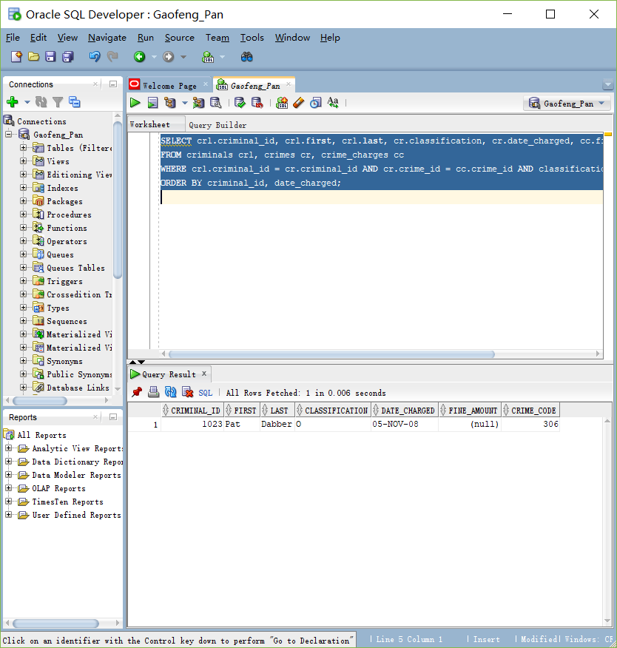

JOIN METHOD

SELECT crl.criminal_id, crl.first, crl.last, cr.classification, cr.date_charged, cc.fine_amount, cc.crime_code

FROM criminals crl

JOIN crimes cr ON crl.criminal_id = cr.criminal_id

JOIN crime_charges cc ON cc.crime_id = cr.crime_id

WHERE classification = 'O'

ORDER BY criminal_id, date_charged;

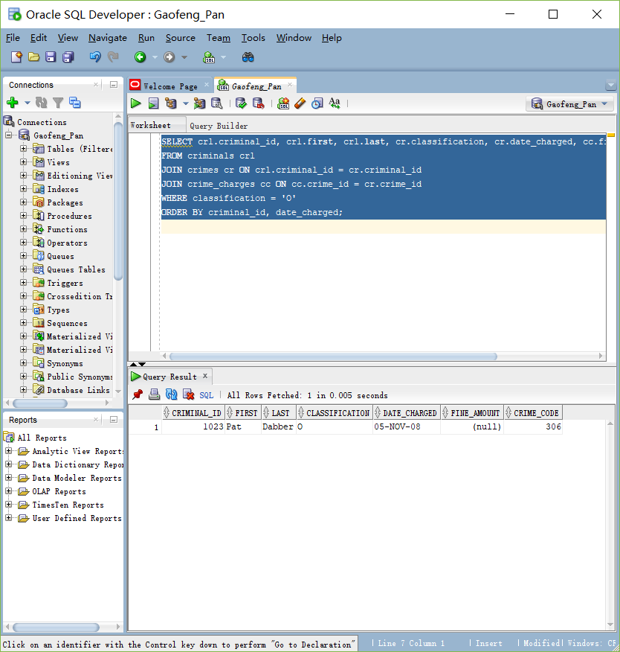

4. Create an alphabetical list of all criminals, including criminal ID, name, violent offender

status, parole status, and any known aliases.

Traditional Method

SELECT c.criminal_id, c.first, c.last, c.v_status, c.p_status, a.alias

FROM criminals c, aliases a

WHERE c.criminal_id = a.criminal_id(+)

ORDER BY c.last, c.first;

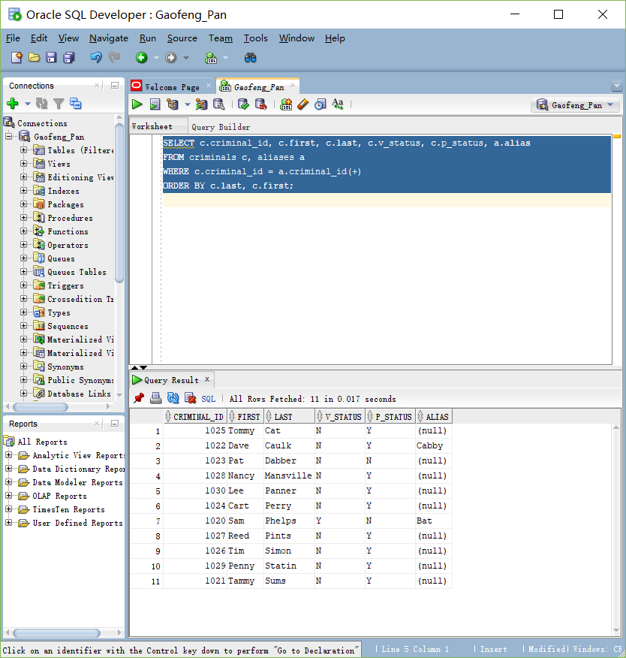

JOIN Method

SELECT c.criminal_id, c.first, c.last, c.v_status, c.p_status, a.alias

FROM criminals c

LEFT OUTER JOIN aliases a ON c.criminal_id = a.criminal_id

ORDER BY last, first;

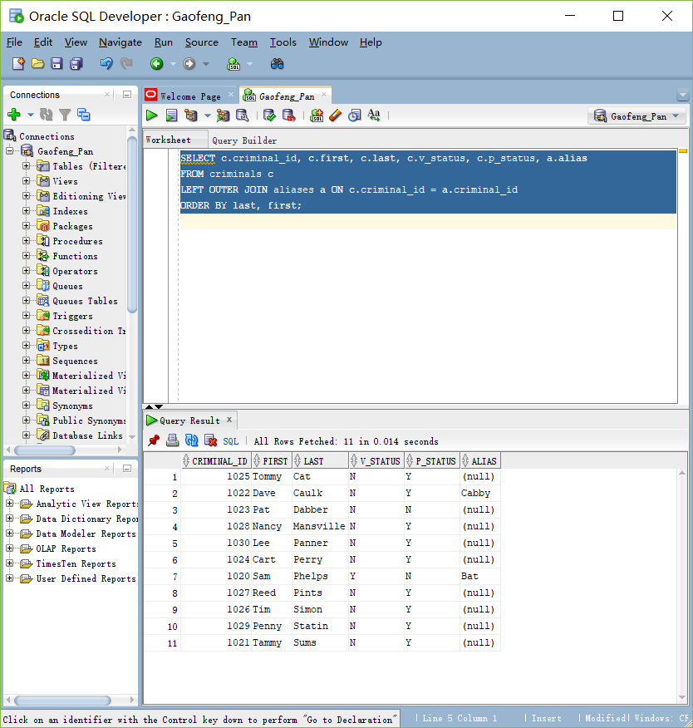

5. A table named Prob_Contact contains the required frequency of contact with a probation

officer, based on the length of the probation period (the number of days assigned to probation).

Review the data in this table, which indicates ranges for the number of days and

applicable contact frequencies. Create a list containing the name of each criminal who has

been assigned a probation period, which is indicated by the sentence type. The list should

contain the criminal name, probation start date, probation end date, and required frequency

of contact. Sort the list by criminal name and probation start date.

Traditional Method

SELECT c.last, c.first, s.start_date, s.end_date, p.con_freq

FROM criminals c, sentences s, prob_contact p

WHERE c.criminal_id = s.criminal_id AND s.end_date - s.start_date >= p.low_amt AND s.end_date - s.start_date <= p.high_amt AND s.type = 'P'

ORDER BY last, first, start_date;

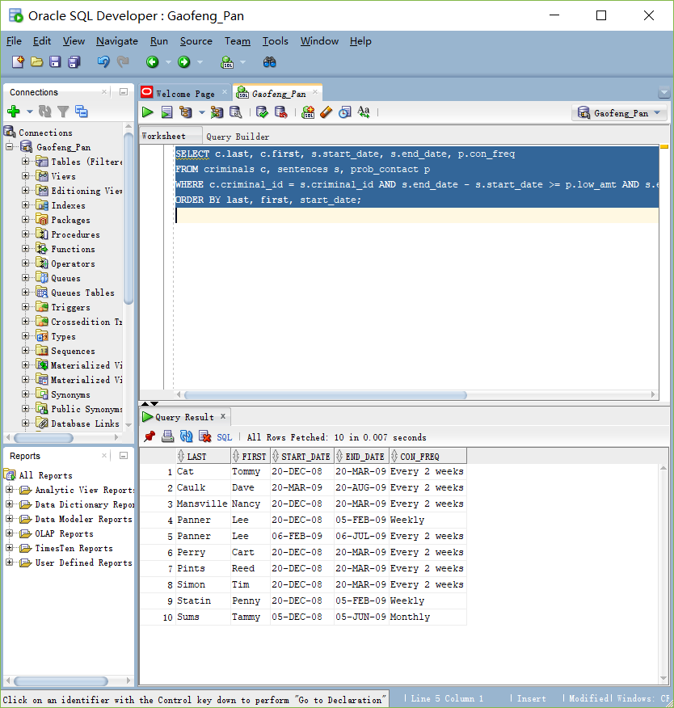

JOIN Method

SELECT c.last, c.first, s.start_date, s.end_date, p.con_freq

FROM criminals c

JOIN sentences s ON s.type = 'P' AND c.criminal_id = s.criminal_id

JOIN prob_contact p ON s.end_date - s.start_date >= p.low_amt AND s.end_date - s.start_date <= p.high_amt

ORDER BY last, first, start_date;

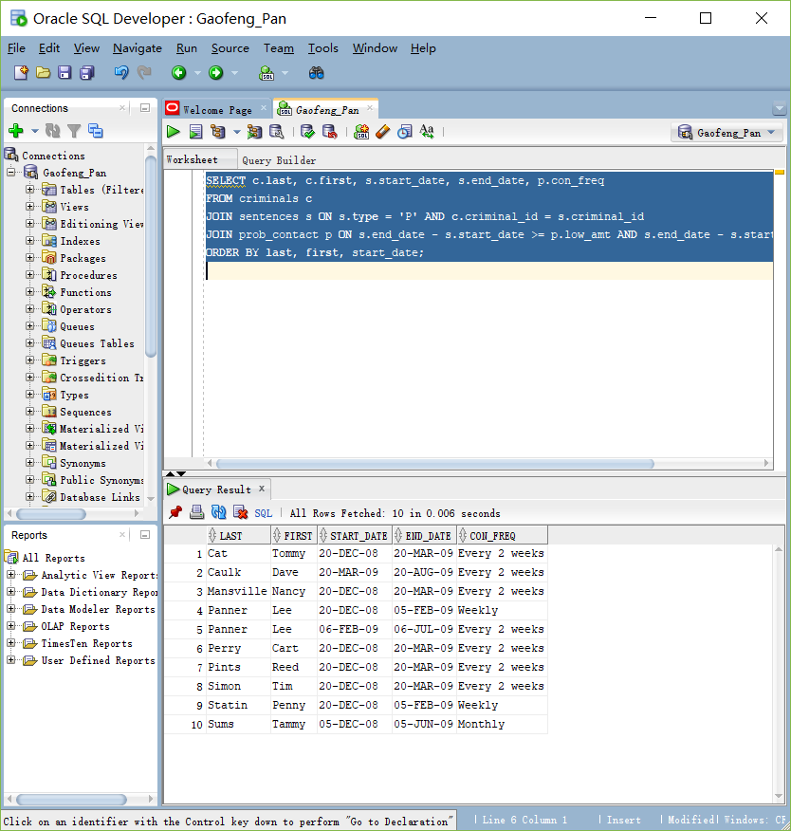

6. A column named Mgr_ID has been added to the Prob_Officers table and contains the ID

number of the probation supervisor for each officer. Produce a list showing each probation

officer’s name and his or her supervisor’s name. Sort the list alphabetically by probation

officer name.

Tradtional Method

SELECT pro.last, pro.first, mgr.last AS "Manager Last Name", mgr.first AS "Manager First Name"

FROM prob_officers pro, prob_officers mgr

WHERE pro.mgr_id = mgr.prob_id(+)

ORDER BY pro.last, pro.first;

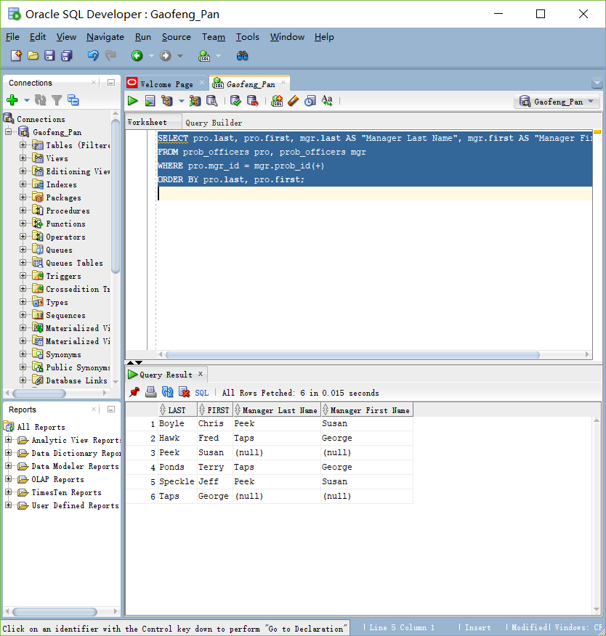

JOIN Method

SELECT pro.last, pro.first, mgr.last AS "Manager Last Name", mgr.first AS "Manager First Name"

FROM prob_officers pro

LEFT OUTER JOIN prob_officers mgr ON pro.mgr_id = mgr.prob_id

ORDER BY last, first;

